**PIZZA SALES SQL QUERIES**

**A. KPI’s**

**1.Total Revenue:**

Select sum(total_price) as Total_Revenue from pizza_sales;

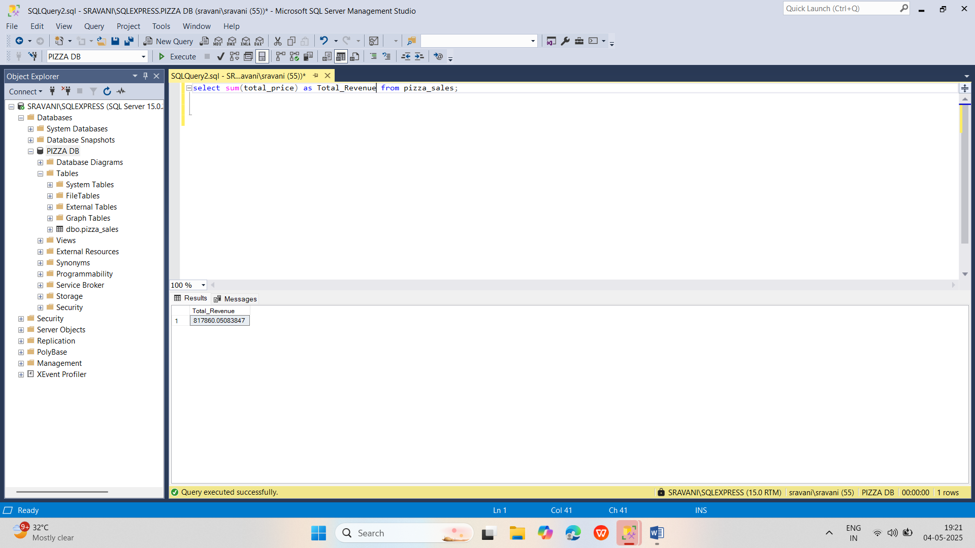

**2.Average Order Value:**

select sum(total_price)/(count(distinct(order_id))) as Average_Order_Value from pizza_sales;

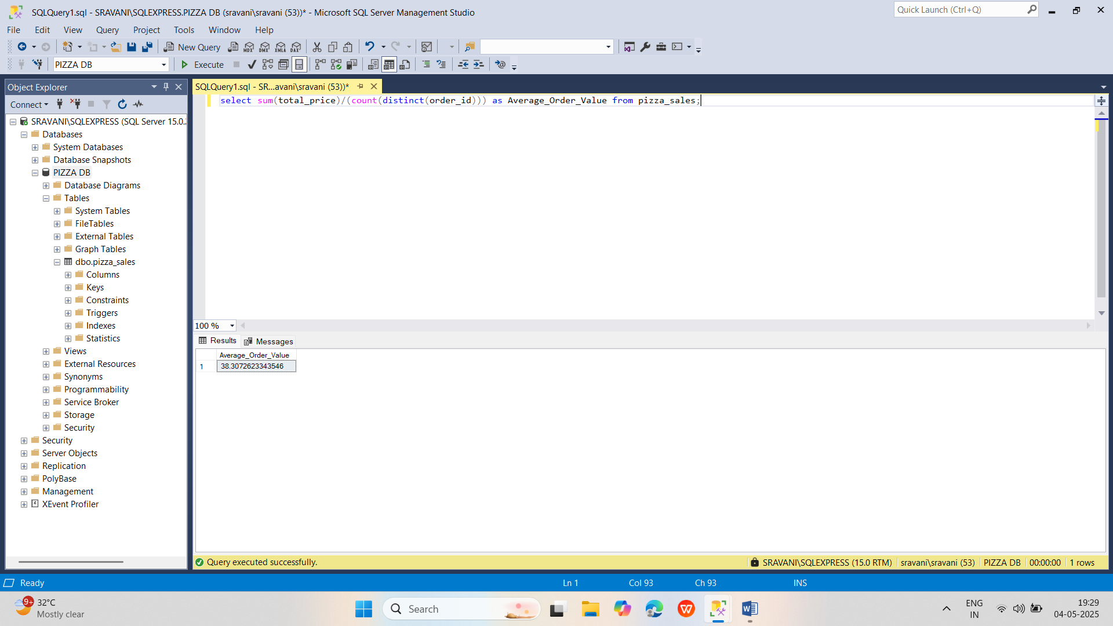

**3.Total Pizza Sold**

select sum(quantity) as Total_Pizza_Sold from pizza_sales;

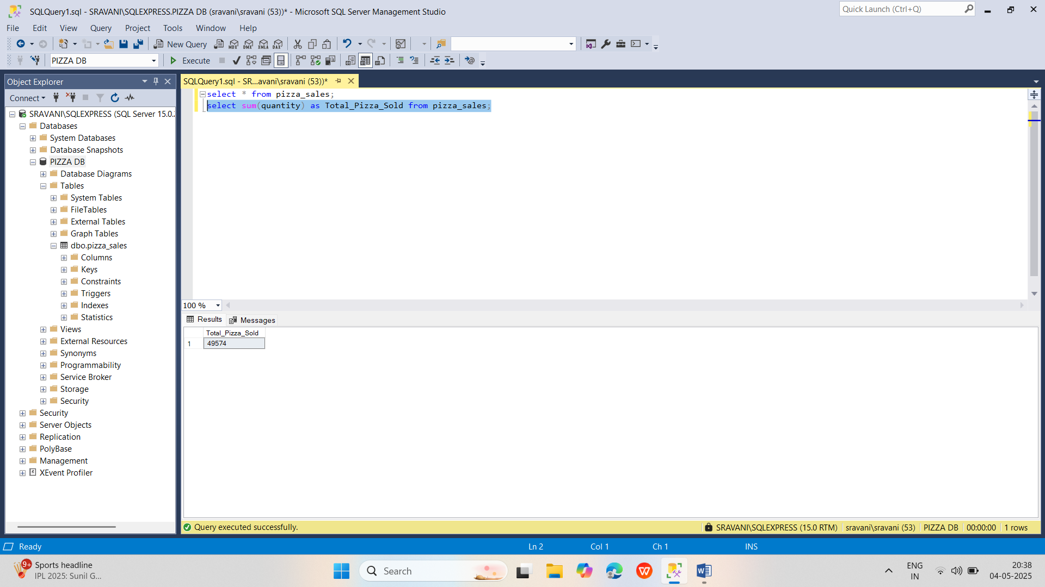

**4.Total Orders**

Select count(distinct(order_id)) from pizza_sales;

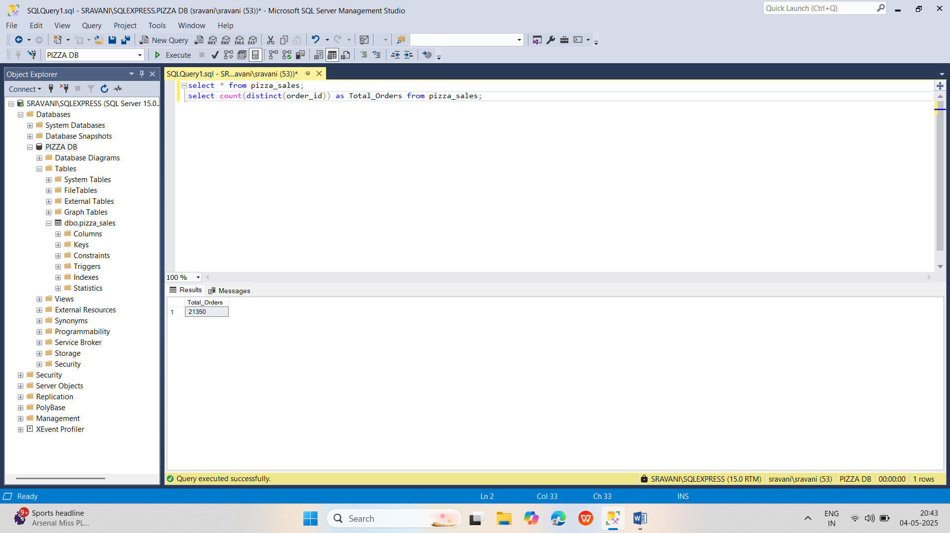

**5.Average Pizzas Per Order**

select cast(cast(sum(quantity) as decimal(10,2))/cast(count(distinct(order_id)) as decimal(10,2)) as decimal(10,2)) as Average_Pizzas_Per_Order from pizza_sales;

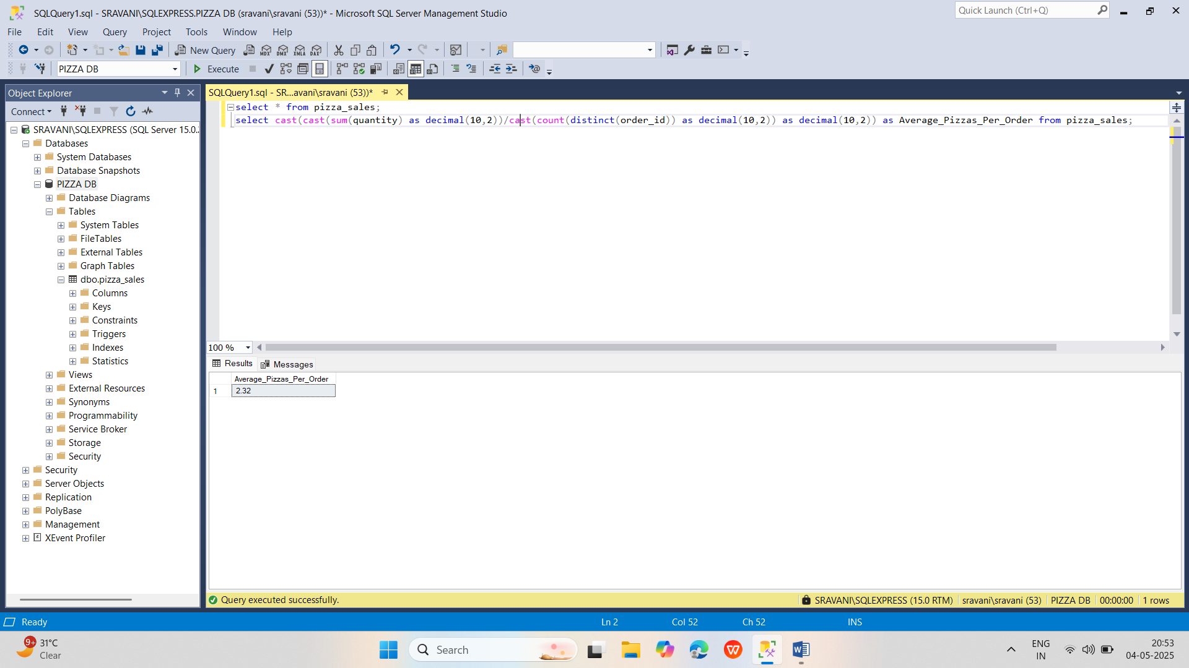

**B.Daily Trend For Total Orders**

select datename(dw,order_date) as week_day,count(distinct(order_id)) as Total_Orders from pizza_sales group by datename(dw,order_date);

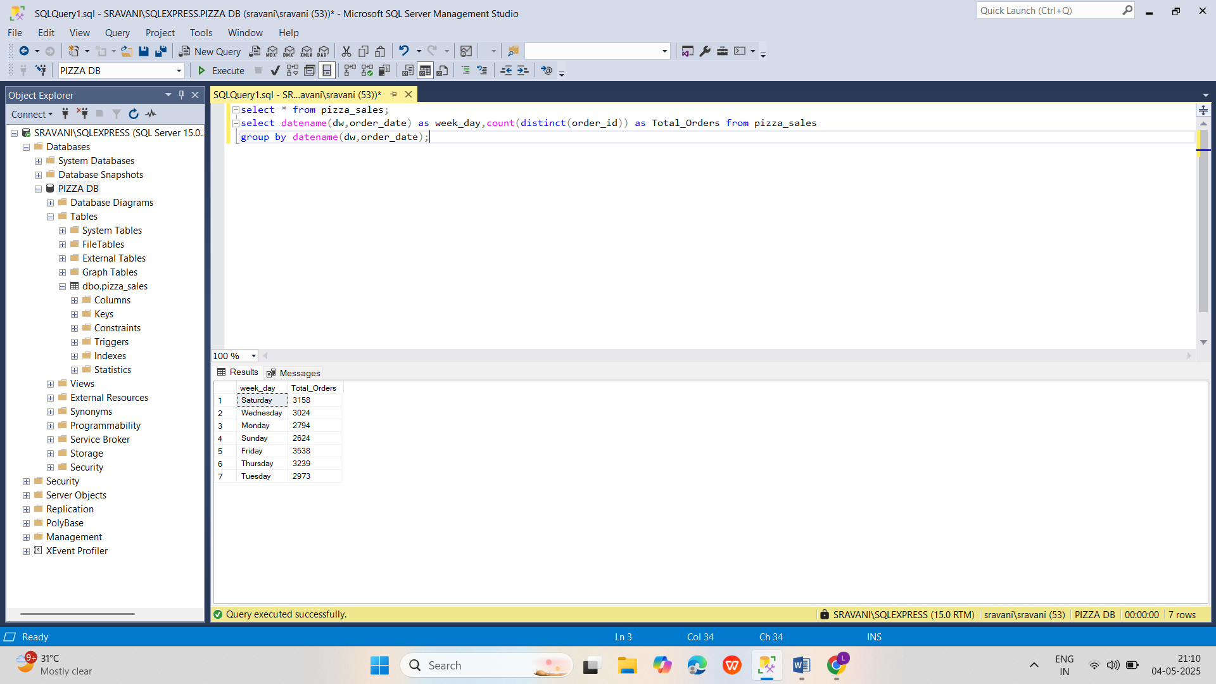

**C.Monthly Trend For Total Orders**

select datename(m,order_date) as Month_Name,count(distinct(order_id)) as Total_Orders from pizza_sales group by datename(m,order_date);

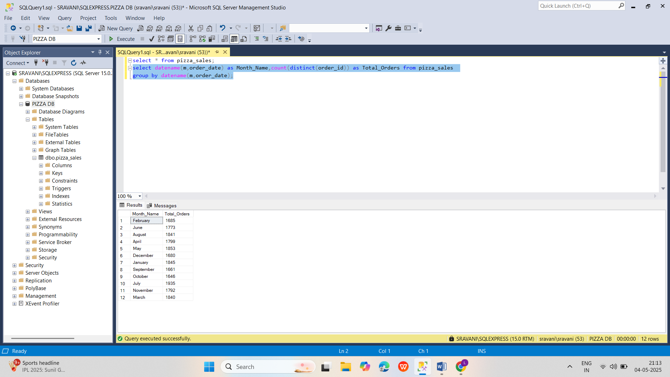

**D.Percentage of Sales By Category**

select distinct(pizza_category),sum(total_price) as Total_Sales,(sum(total_price)*100)/(select sum(total_price) from pizza_sales) as PCT

from pizza_sales where month(order_date)=2 group by pizza_category;

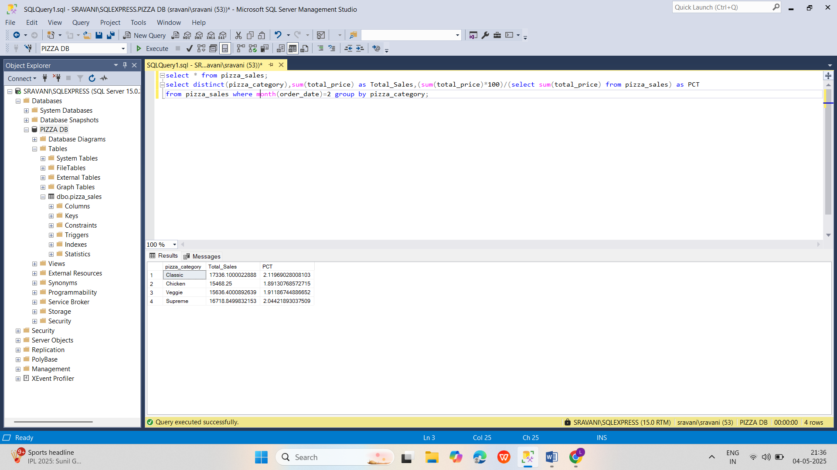

**E.Percentage of Sales by Pizza Size**

select distinct(pizza_size),cast(sum(total_price) as decimal(10,2)) as Total_Sales,cast(cast((sum(total_price)*100)/(select sum(total_price) from pizza_sales) as decimal(10,2)) as varchar(10)) + '%' as PCT

from pizza_sales where datepart(quarter,order_date)=1 group by pizza_size order by PCT desc;

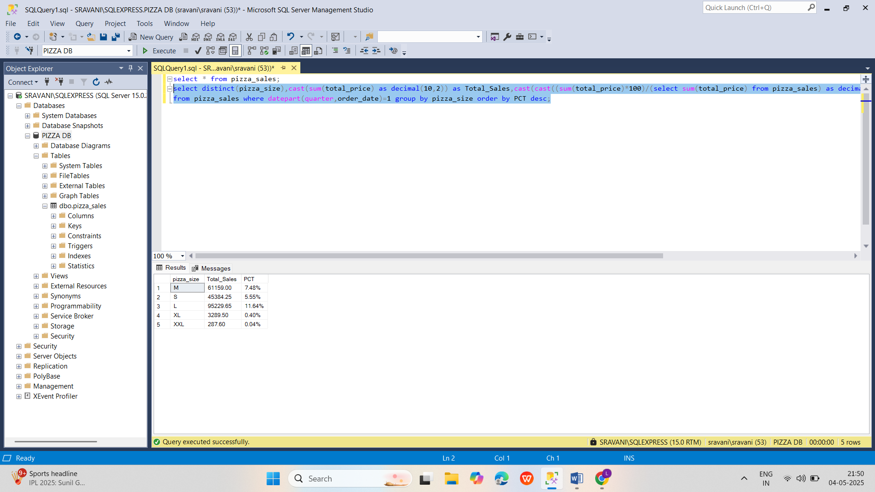

**F.Total Pizzas Sold by Category**

select pizza_category as Pizza_Category,sum(quantity) as Total_Pizzas from pizza_sales group by Pizza_Category;

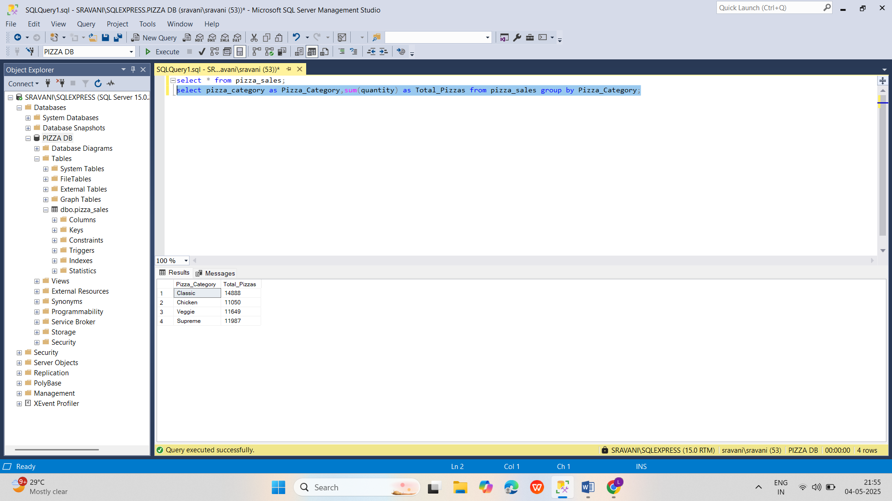

**G.Top 5 Pizzas by Revenue**

select top 5 pizza_name,sum(total_price) as Total_Revenue from pizza_sales group by pizza_name order by Total_Revenue desc;

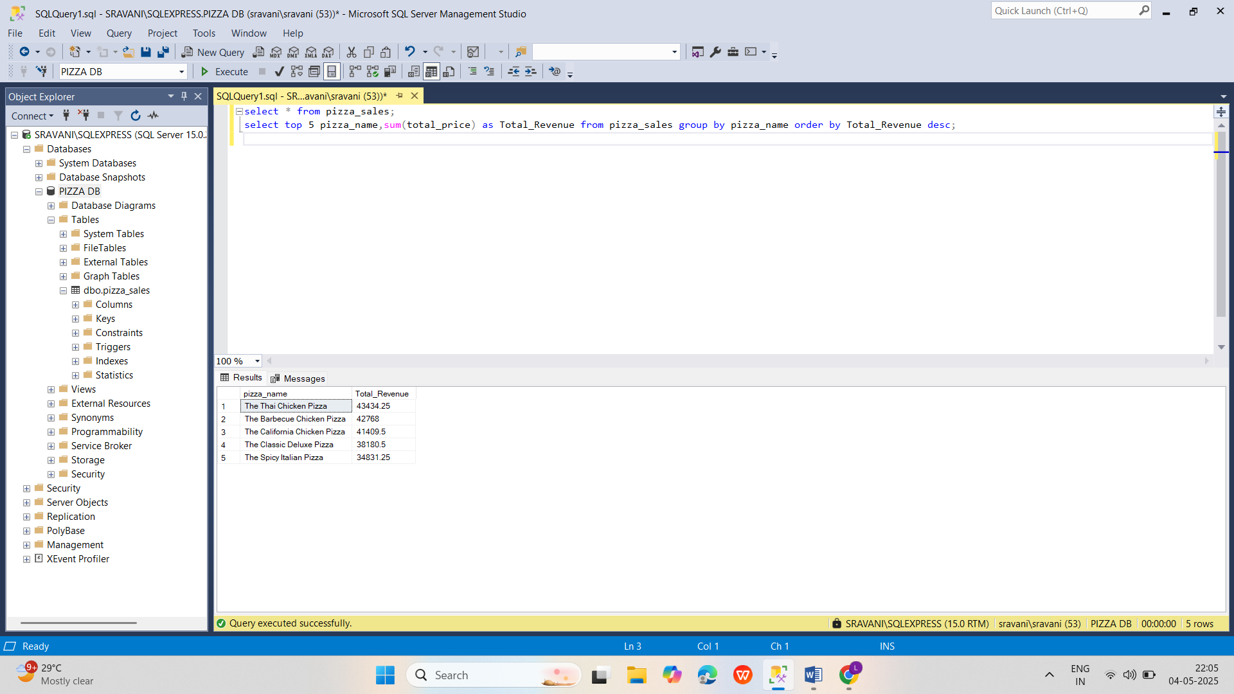

**H.Bottom 5 Pizzas by Revenue**

select top 5 pizza_name,sum(total_price) as Total_Revenue from pizza_sales group by pizza_name order by Total_Revenue asc;

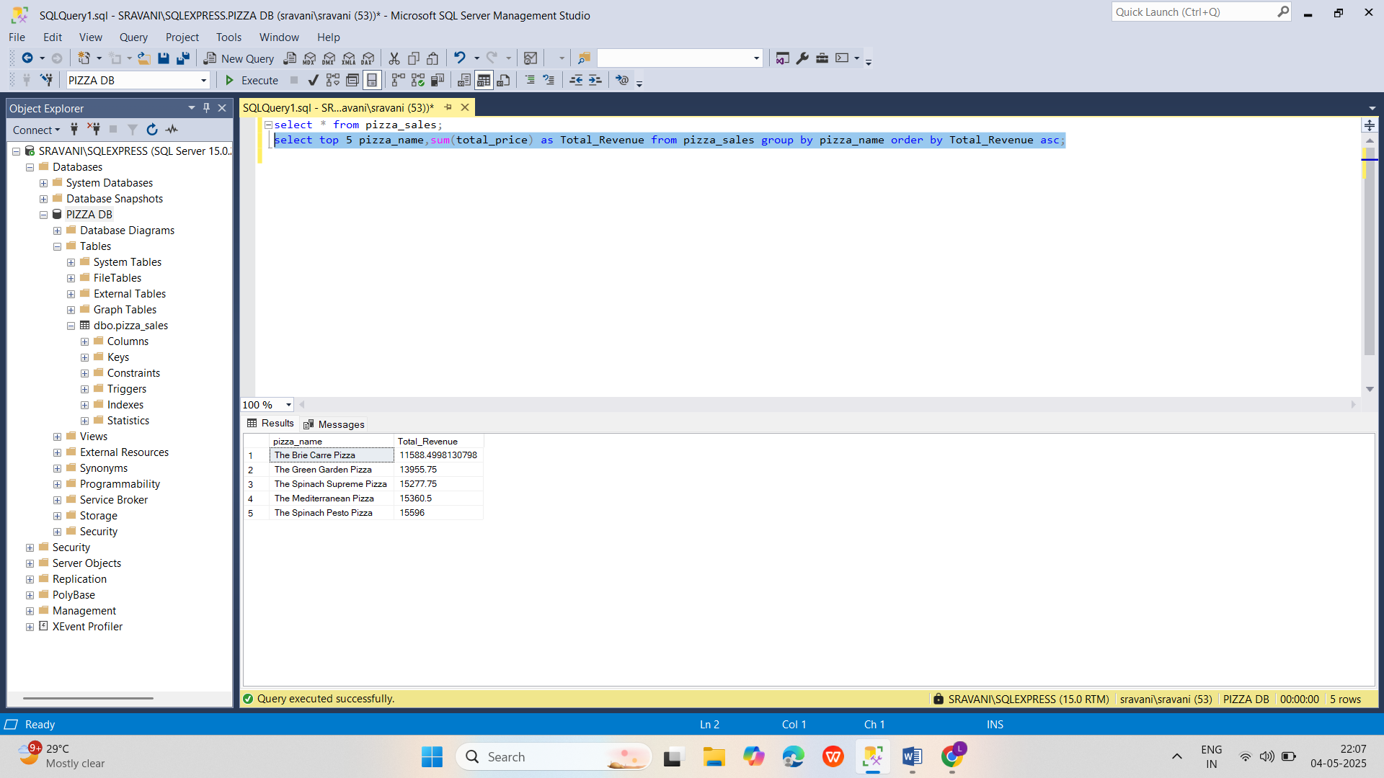

**I.Top 5 Pizzas by Quantity**

select top 5 pizza_name,sum(quantity) as Total_Quantity from pizza_sales group by pizza_name order by Total_Quantity desc;

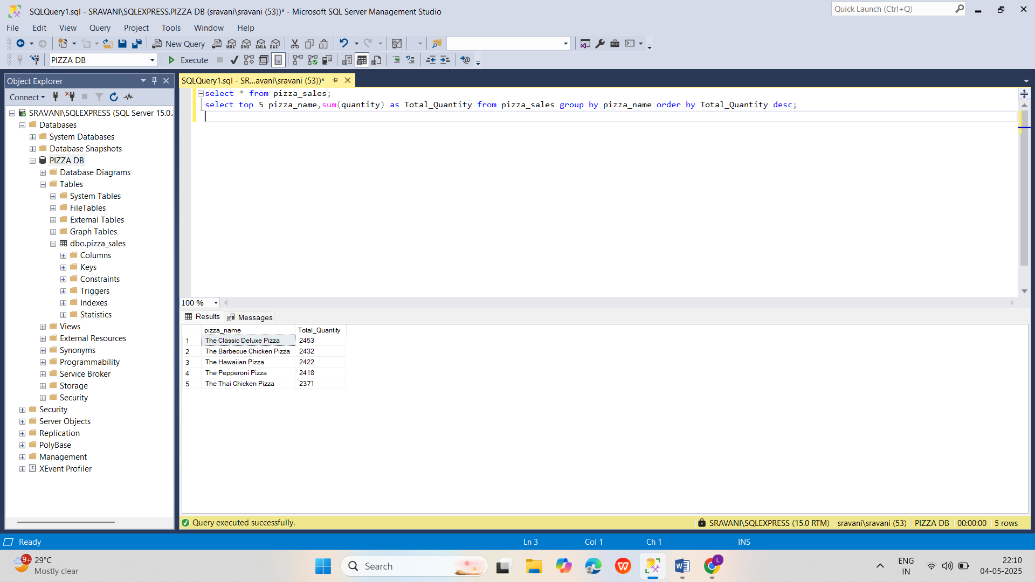

**J.Bottom 5 Pizzas by Quantity**

select top 5 pizza_name,sum(quantity) as Total_Quantity from pizza_sales group by pizza_name order by Total_Quantity asc;

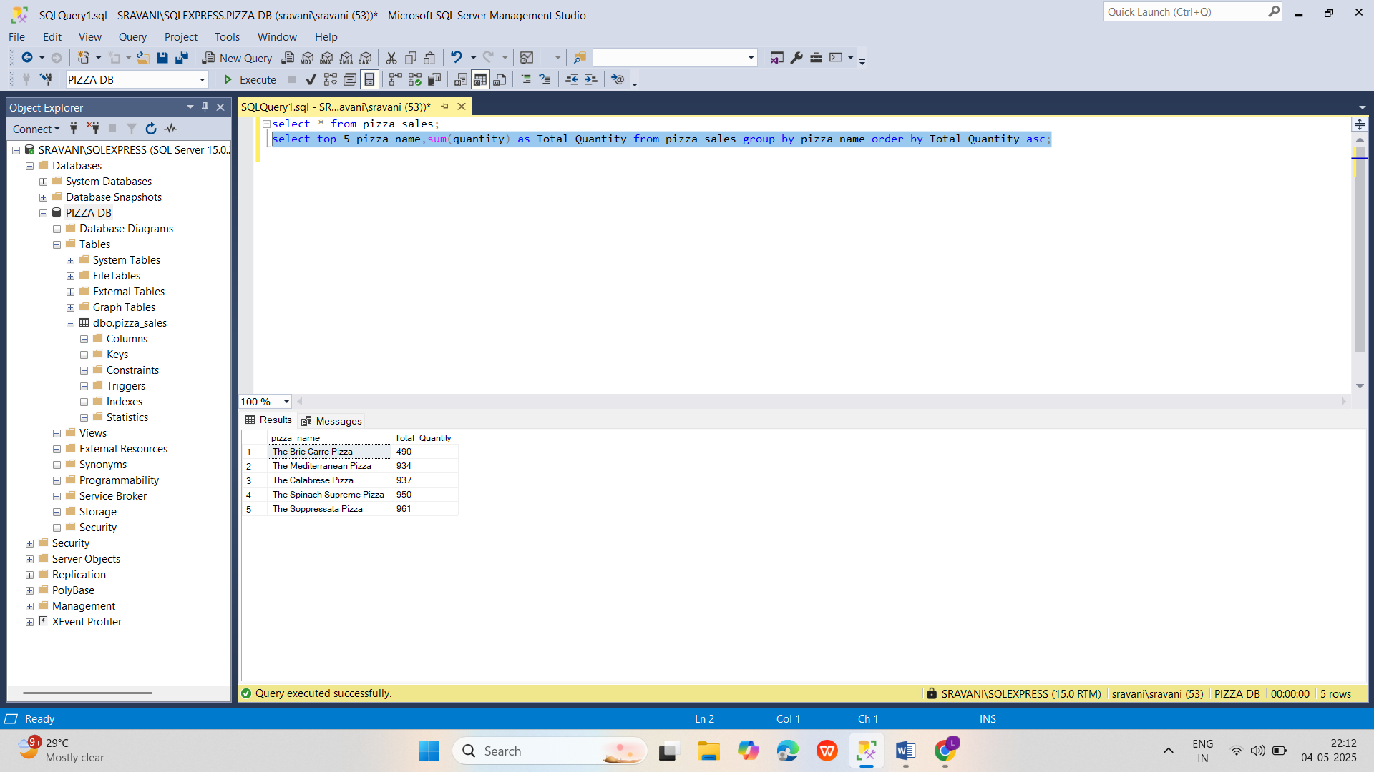

**K.Top 5 Pizzas by Total Orders**

select top 5 pizza_name,count(distinct order_id) as Total_Orders from pizza_sales group by pizza_name order by Total_Orders desc;

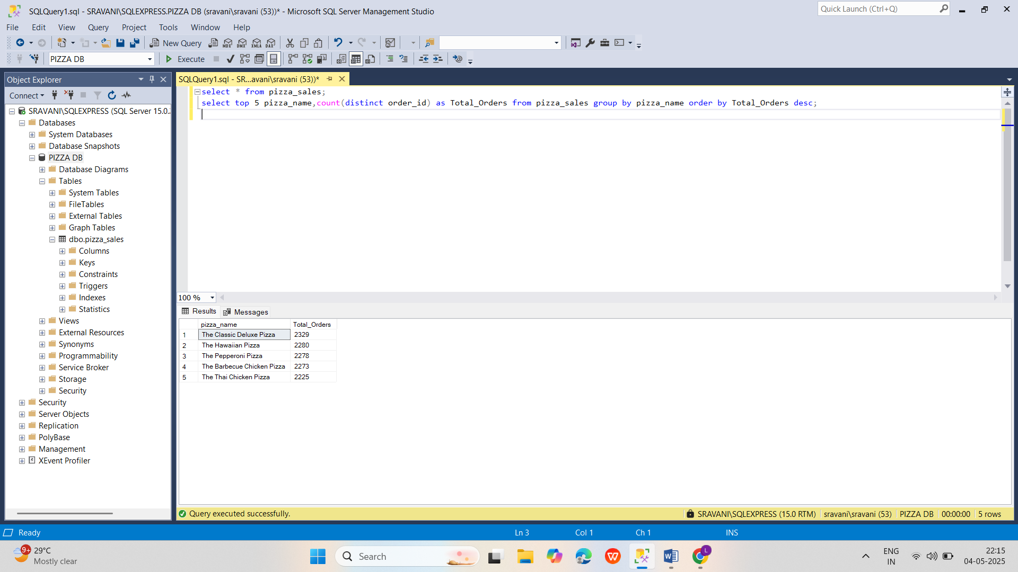

**L.Bottom 5 Pizzas by Total Orders**

select top 5 pizza_name,count(distinct order_id) as Total_Orders from pizza_sales group by pizza_name order by Total_Orders asc;

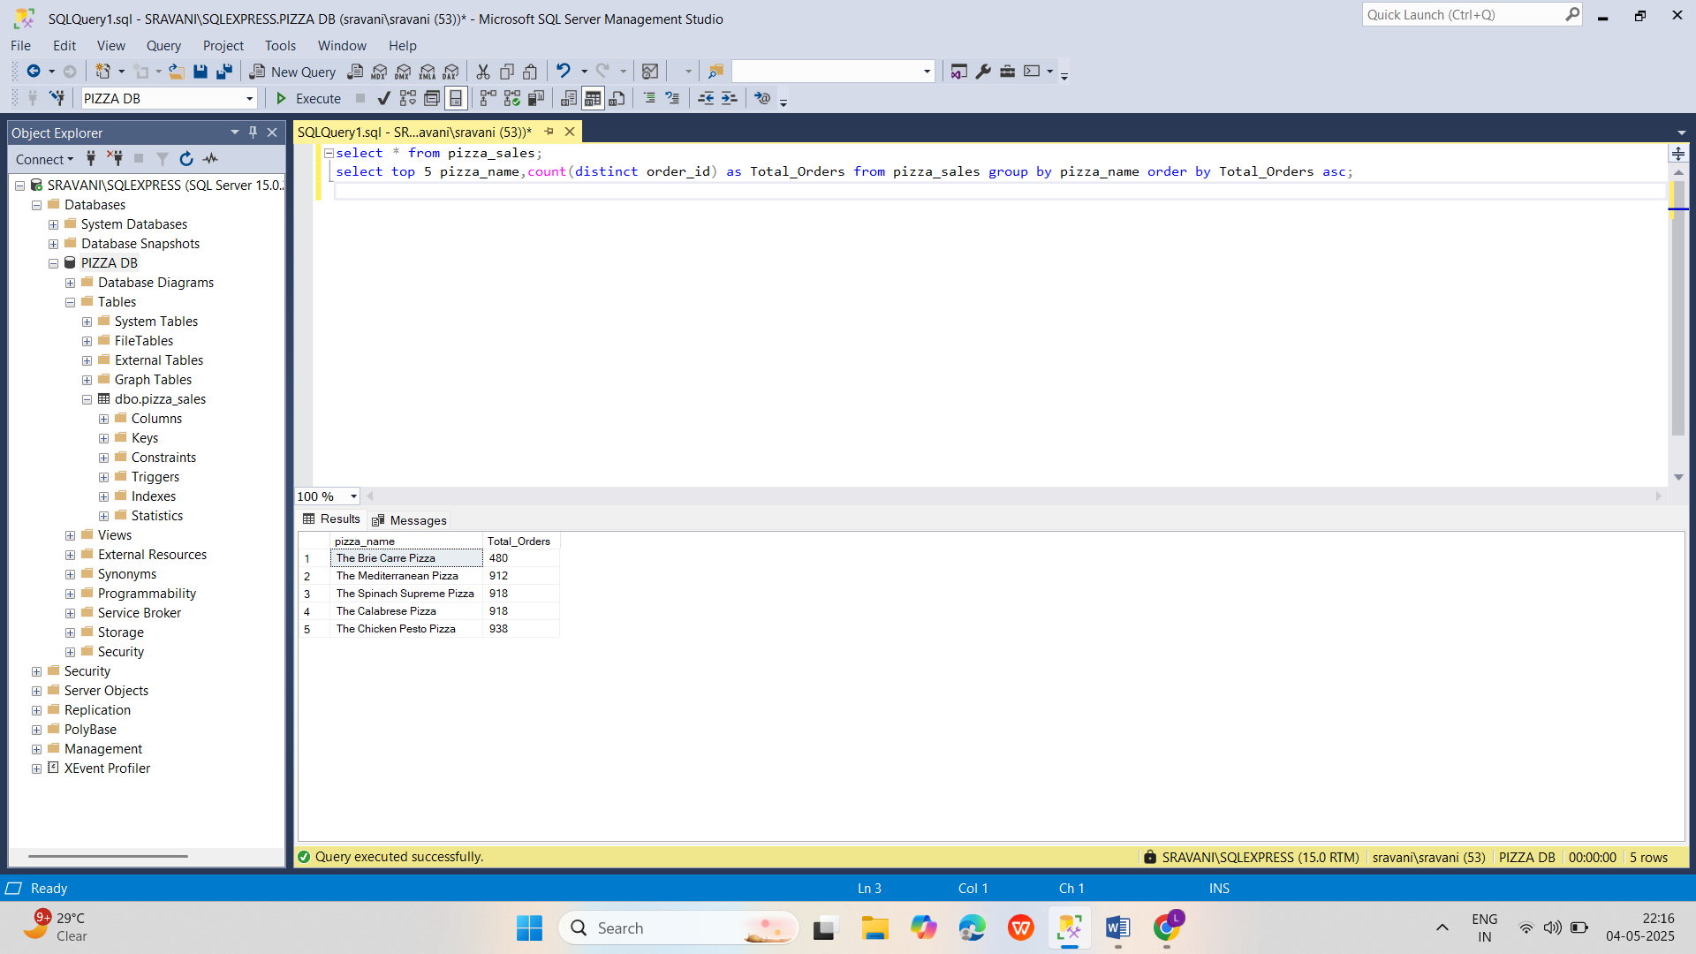

***NOTE***

If you want to apply the pizza_category or pizza_size filters to the above queries you can use WHERE clause. Follow some of below examples

SELECT Top 5 pizza_name, COUNT(DISTINCT order_id) AS Total_Orders

FROM pizza_sales

WHERE pizza_category = 'Classic'

GROUP BY pizza_name

ORDER BY Total_Orders ASC